Losses for dummies

Ref:
- https://gombru.github.io/2018/05/23/cross_entropy_loss/
- https://pytorch.org/docs/stable/nn.html
- slides (L10, L20)
- telegram
- about activation functions, one of the many resources: https://missinglink.ai/guides/neural-network-concepts/7-types-neural-network-activation-functions-right/

Basic introduction

Correlated concepts: risk, empirical risk, empirical risk minimization … (ref: L10, L20)

(lecture 10 MLDL)

General principle: the loss, in a ML setting, is a function that describes the penalties when taking wrong decisions.
E.g. in a classification setting, the loss may be represented as a function f(a_i | w_j) that describes the penalty of taking action a_i, when the state of nature is w_j.

(lecture 20 MLDL)

Suppose we’re operating in a supervised learning setting (labelled training set).
Given a training set D made up of m samples and split into train/test data as:

D = {(X1,Y1) … (XN, YN)} U
{(XN+1, YN+1) … (XM, YM)}

We may define a loss function L as:
L(x, y, f(x)) where L: X x Y x R => [0, +inf]

- Interpretation of the loss function: measure of how good we’re at classifying a particular (x,y) pair, in a classification setting.
- Objective: we want the loss to be small for many (X_i, Y_i) pairs in the test data
- (Naive) Examples (see slides):
- Binary classification loss, either you get it right or wrong
- Squared Loss (= L2 loss), I’m “kind” with small mistakes
- L1 loss, highly penalizing small mistakes
- Hinge loss, penalizes predictions which are < 1, commonly used in SVM

Losses in our DL projects

During our projects using deep NN we’ve mainly used the following Pytorch’s losses:
- Cross entropy loss
- Binary cross entropy loss
- Binary cross entropy loss with logits
All of the above are multi-class classification losses.
Note: A multi-class classification problem is one in which each sample from the dataset might belong to one of many classes (N), so that the NN (ex. CNN) will have N output neurons (task = single classification problem of samples in one of the N classes).

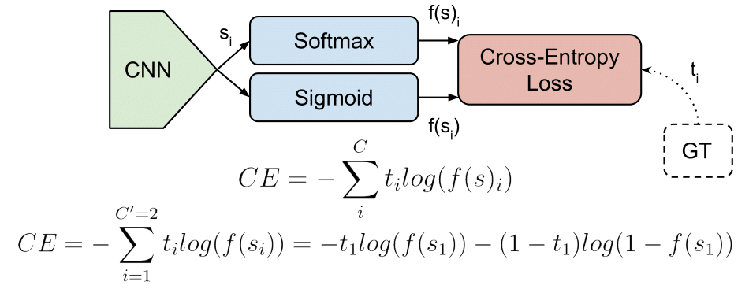

Pipeline example

Picking a CNN setting, before the computation of the loss we apply to the vectors coming out of the CNN a function, that is called activation function (activation functions are responsible basically for deciding whether a neuron should be “fired” (remember analogy with the human brain) and might also be useful to normalize the output of each neuron).
Examples of activation functions (reviewed in class):
- Sigmoid
- Softmax
- ReLU
See the details here:
- https://gombru.github.io/2018/05/23/cross_entropy_loss/
- https://missinglink.ai/guides/neural-network-concepts/7-types-neural-network-activation-functions-right/
- Stanford notes …

More on the losses (finally)

- Cross-entropy loss

- Definition: 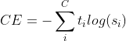, where t_i = groundtruth s_i = CNN score, for each class i in our multi-class problem.
- Notes:
  - usually an activation function, i.e Sigmoid or Softmax, is applied to the scores (output of the CNN) before the CE loss computation.
  - CE loss = logistic loss = multinomial logistic loss

- Binary cross-entropy loss

- Definition: 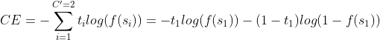, where t_i = groundtruth s_i = CNN score, for each class i in our multi-class problem, f(s_i) activation functions.
- Notes:
  - It is a sigmoid activation plus a Cross-Entropy loss.
  - It is used, again, for multi label classification (it’s independent for each class)
  - It basically setup a binary classification problem for all the N classes in our problem

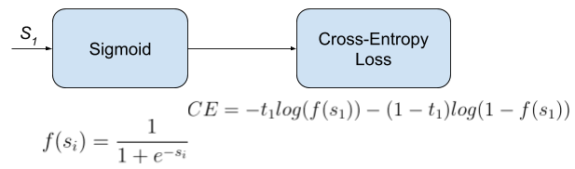
BCE loss representation, pipeline for each of the N classes

- BCE with logits loss

Pytorch, which messes up the things, call BCEwithlogits loss the loss that combines a sigmoid layer and the BCE loss in one single class (according to the documentation this version is more stable than using simply a manual combination of sigmoid + BCE loss).

From documentation…

The unreduced (i.e. with reduction set to 'none') loss can be described as:
ℓ(x,y)=L={l1,…,lN}⊤,ln=−wn[yn⋅log⁡σ(xn)+(1−yn)⋅log⁡(1−σ(xn))],ℓ(x,y)=L={l1​,…,lN​}⊤,ln​=−wn​[yn​⋅logσ(xn​)+(1−yn​)⋅log(1−σ(xn​))],
where NN is the batch size. If reduction is not 'none' (default 'mean'), then
ℓ(x,y)={mean⁡(L),if reduction=’mean’;sum⁡(L),if reduction=’sum’.ℓ(x,y)={mean(L),sum(L),​if reduction=’mean’;if reduction=’sum’.​
This is used for measuring the error of a reconstruction in for example an auto-encoder. Note that the targets t[i]should be numbers between 0 and 1.
Further details on official Pytorch documentation.

